PROJECT REPORT DEMONSTRATION

1 INTRODUCTION

OVERVIEW

Designing A Book cover Using Canva

The Creating Informatic in Book cover for college presentation using canva the project focus on developing visually enhancing and informatics Book cover to enhance the quality effectiveness of college presentation.

PURPOSE

The Project assigned that the skills of using technology to create the designing book cover using Canva with help of canva application

2. PROBLEM DEFINITIONS AND DESIGNIN THINKING

EMPATHY MAP

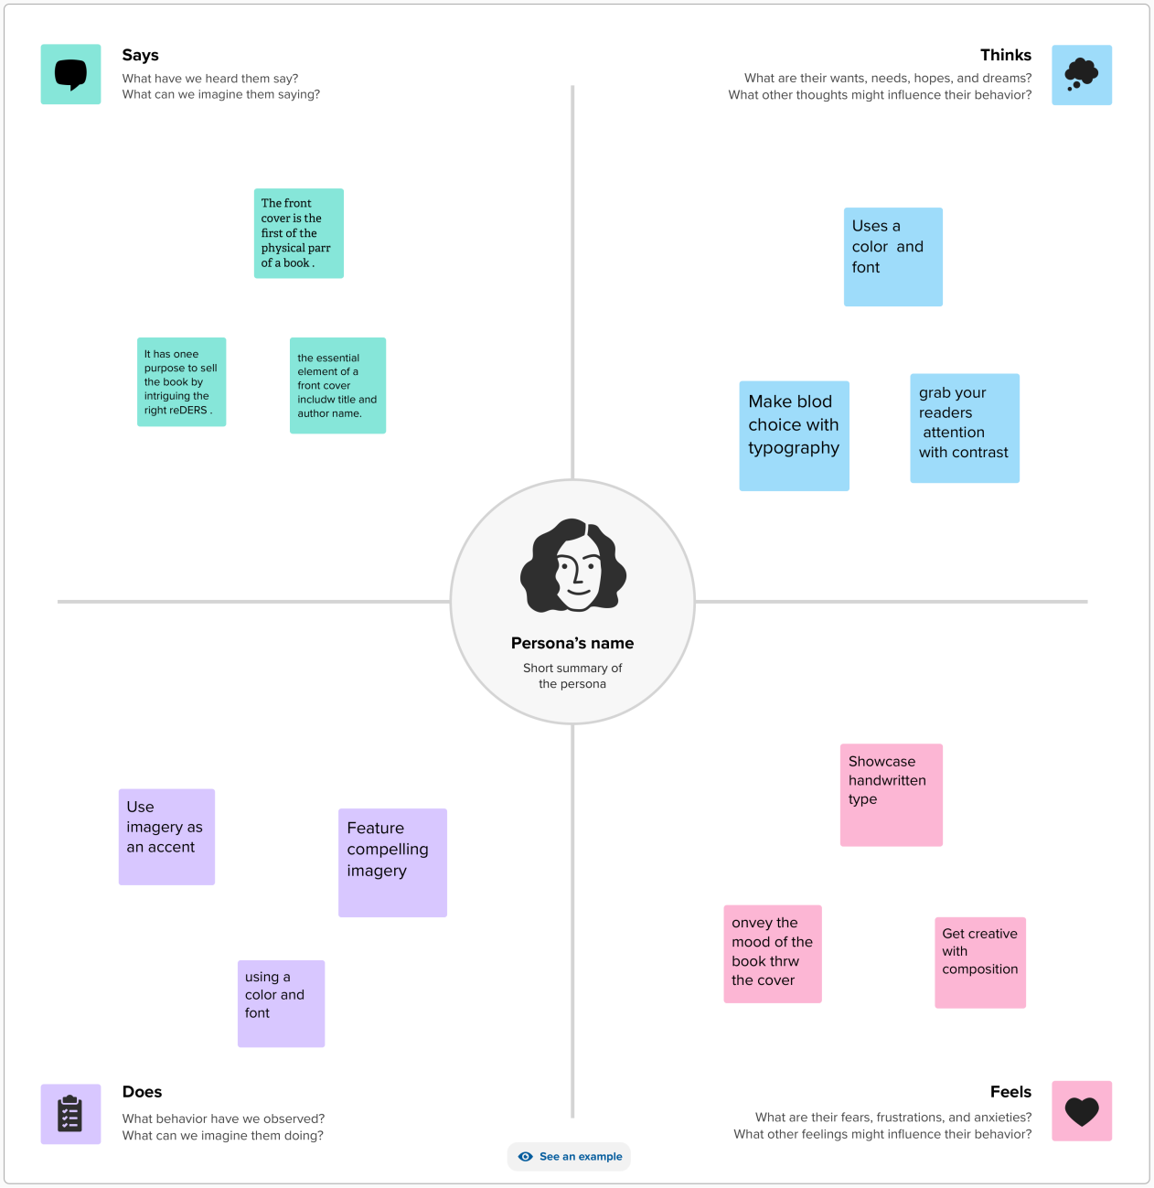

BRAINSTORMING MAP

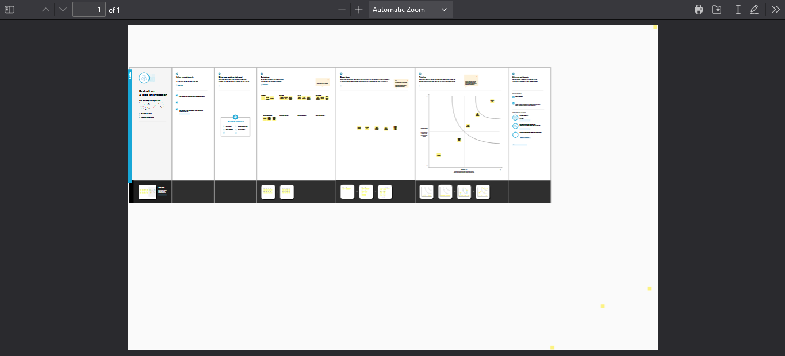

3. RESULTS

PROJECT NAME DESIGN INFRAGRAPHIS USING CANVA

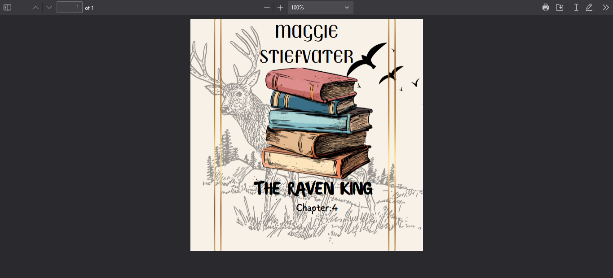

4. ADVANTAGES AND DISADVANTAGES

|  |  |
| --- | --- |
| . ADVANTAGES | DISADVANTAGES |
| 1. It is used effectively in communication 2. It is economical 3. It is User-Friendly 4. In Canva There are a lot of activities for presentation | 1.Some logo ,images,designs are so costly  2. E-mail Id is mandatory |
|  |  |

5 APPLICATION

THE CANVA Application is very useful to create my project easily . it helps with new templates

It will be useful in my future.

6 CONCLUSION

In NAAN MUDHALVAN SCHEME I am a student in Ramanas college ofArts and Science chidambarapuram, assigned my project to be done with help of Canva Application.I have learned that usage of canva App well and It is very user-friendly.